Smart Parking

Definition:

Smart parking, utilizing IoT (Internet of Things) sensors, refers to a modern parking management system that leverages sensor technology and data connectivity to optimize the utilization and efficiency of parking spaces. It involves the deployment of various sensors, such as ultrasonic, magnetic, or camera-based devices, in parking areas to monitor and collect real-time data about parking space occupancy and availability.

Material Required:

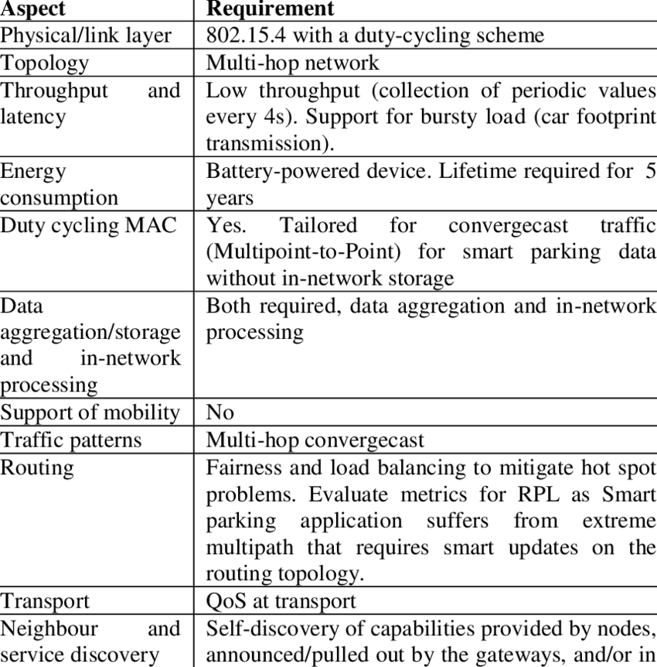

Circuit Diagram:

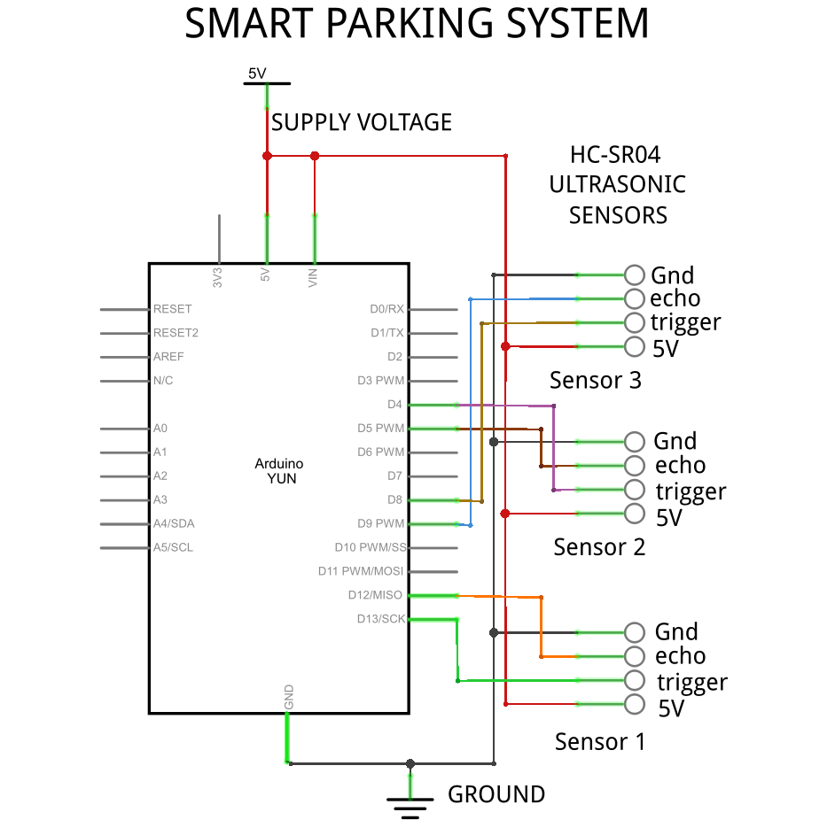

Actual Circuit:

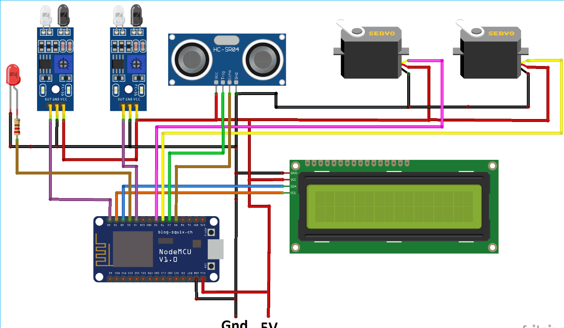

Coding:

import RPi.GPIO as GPIO

import time

# GPIO pins for the ultrasonic sensor

TRIG_PIN = 23 # GPIO23

ECHO_PIN = 24 # GPIO24

# Simulated parking spaces (in a real application, you would have more spaces)

parking_spaces = {

1: {"available": True},

2: {"available": True},

}

# Set up GPIO

GPIO.setmode(GPIO.BCM)

GPIO.setup(TRIG_PIN, GPIO.OUT)

GPIO.setup(ECHO_PIN, GPIO.IN)

# Function to measure distance using the ultrasonic sensor

def measure_distance():

GPIO.output(TRIG_PIN, GPIO.LOW)

time.sleep(2)

GPIO.output(TRIG_PIN, GPIO.HIGH)

time.sleep(0.00001)

GPIO.output(TRIG_PIN, GPIO.LOW)

while GPIO.input(ECHO_PIN) == 0:

pulse_start = time.time()

while GPIO.input(ECHO_PIN) == 1:

pulse_end = time.time()

pulse_duration = pulse_end - pulse_start

distance = pulse_duration * 17150 # Speed of sound = 34300 cm/s

return distance

try:

while True:

for space_id in parking_spaces:

distance = measure_distance()

if distance < 10: # Adjust this threshold based on your setup

parking_spaces[space_id]["available"] = False

else:

parking_spaces[space_id]["available"] = True

print("Parking Space Status:")

for space_id, status in parking_spaces.items():

print(f"Space {space_id}: {'Available' if status['available'] else 'Occupied'}")

time.sleep(2)

except KeyboardInterrupt:

GPIO.cleanup()

Output:

If Parking Space 1 is Available then the Output is,

Parking Space Status:

Space 1: Available

Space 2: Occupied

Uses:

1. **Optimized Parking**: The primary purpose of smart parking systems is to optimize parking space utilization. They help drivers quickly locate and secure available parking spaces, reducing the time spent searching for a spot.
2. **Reduced Traffic Congestion**: By helping drivers find parking spaces more efficiently, smart parking systems can reduce traffic congestion in urban areas. This leads to smoother traffic flow, lower fuel consumption, and reduced greenhouse gas emissions.
3. **Improved User Experience**: Smart parking systems enhance the overall user experience for drivers. Users can check space availability in real-time, reserve parking spots in advance, and make cashless payments.
4. **Space Monitoring**: IoT sensors can continuously monitor parking spaces and provide real-time data on occupancy and availability. This data can be used by parking operators to make informed decisions.
5. **Revenue Generation**: Smart parking systems can increase revenue for parking facility operators by improving space utilization, enabling dynamic pricing based on demand, and reducing ticketing and operational costs.
6. **Environmental Impact**: Reducing traffic congestion and emissions by optimizing parking benefits the environment. It contributes to more sustainable and eco-friendly urban environments.
7. **Safety**: IoT sensors can be used to monitor and manage parking areas for safety. For example, they can detect unauthorized or dangerous parking and alert authorities.
8. **Accessibility**: Smart parking systems can help make parking facilities more accessible by providing information about available accessible parking spaces to drivers with disabilities.
9. **Predictive Analytics**: By collecting historical data on parking space usage, smart parking systems can offer predictive analytics. This helps in planning for peak parking demand and optimizing space allocation.
10. **Security**: IoT sensors can enhance the security of parking areas by detecting unusual or suspicious activities and triggering alerts.
11. **Integration with Navigation Systems**: Many smart parking systems can be integrated with GPS and navigation systems, allowing drivers to be guided to available parking spaces in real-time.
12. **IoT Ecosystem Integration**: Smart parking is part of the broader Internet of Things (IoT) ecosystem. Data from parking sensors can be integrated with other IoT devices and systems to improve urban planning, traffic management, and public safety.
13. **Urban Planning**: Data collected by smart parking systems can be valuable for urban planners and city officials. It helps in designing better transportation infrastructure and improving the overall layout of cities.
14. **Time Savings**: Drivers save time by quickly finding available parking spaces, which can improve productivity and reduce stress.
15. **Contactless Payments**: Smart parking systems can facilitate contactless payments, enhancing convenience and safety for users.

Conclusion:

Smart parking systems are a vital component of the broader smart city movement, improving the quality of life in urban areas. They address the challenges of urbanization and mobility, providing a practical solution to the age-old problem of finding a parking space. As technology continues to advance, smart parking systems are likely to become more sophisticated, further transforming urban transportation and contributing to a sustainable, efficient, and connected urban future.

Team Members:

1. Kevin Easter Raj A(112821104042)
2. Karthick M(112821104040)
3. Meiya Perumal M(112821104305)
4. Mokesh G P(112821104045)
5. Saran S(112821104060)